1. Executive Summary & Abstract
1.1 Abstract
Industrial automation modernizes manufacturing by improving production throughput, operational precision, and workplace safety. This project proposal outlines the technical architecture, control logic, hardware selection, and safety protocols for a Programmable Logic Controller (PLC)-based Automated Bottling and Sorting System.
The proposed system automates the end-to-end container conveying, liquid filling, capping, quality inspection, and sorting processes. Utilizing a modular Siemens S7-1200 PLC architecture integrated with Human-Machine Interface (HMI) visualization, photoelectric sensors, and pneumatic actuators, the design minimizes human error, optimizes cycle times, and provides real-time diagnostic reporting.
1.2 Document Overview
- Target Application: High-speed beverage/fluid packaging lines.
- Control Platform: Siemens S7-1200 (CPU 1214C DC/DC/DC).
- Programming Standard: IEC 61131-3 (Ladder Diagram / Structured Text).
- Primary Objective: Deliver a complete engineering proposal suitable for implementation, testing, and submission for the internship portfolio.
2. System Overview & Objectives
2.1 Problem Statement
Manual and semi-automated fluid bottling lines suffer from variable fill volumes, frequent operational bottlenecks, high labor expenses, and elevated workplace hazard exposure. Uncontrolled manual sorting further increases product error rates during packaging.
2.2 System Objectives
- Automate Motion & Conveyance: Manage variable-speed conveyor operations via Variable Frequency Drives (VFDs).
- Precision Filling & Capping: Control liquid dispensation using solenoid pulse valves with volumetric feedback to achieve volumetric tolerance within $±1\%$.
- Automated Defect Rejection: Integrate optical proximity and vision-based height sensors to reject improperly filled or uncapped containers.
- Safety & Monitoring: Implement safety interlocks compliant with SIL 2 / PL d standards and provide localized HMI system diagnostics.
3. Hardware Architecture & Hardware Selection
3.1 PLC Controller Specification
The selected control engine is the Siemens SIMATIC S7-1200 (CPU 1214C DC/DC/DC) due to its modular expandability, integrated PROFINET Ethernet interface, and embedded high-speed counters.
Component | Specification | Function / Justification
Main Controller | Siemens S7-1200 (CPU 1214C) | Executes control algorithms and processes I/O signals
Digital Inputs (DI) | 14 Onboard 24V DC Inputs | Reads sensors, pushbuttons, and interlocks
Digital Outputs (DO) | 10 Onboard Transistor Outputs | Controls solenoids, contactors, and status indicators
Analog Expansion Module | SM 1231 AI 4 x 13 bit | Reads flow rate and pressure transducer signals
Communication Interface | PROFINET / Ethernet RJ-45 | HMI connection and programming access
HMI Panel | Siemens KTP700 Basic (7-inch) | Graphical process monitoring and alarm logging
3.2 Sensor & Actuator Mapping
Input Devices (Sensors & Field Signals)
- Bottle Presence Sensor ($S_{1}$): Diffuse photoelectric sensor detecting incoming empty bottles on the primary conveyor.
- Liquid Level Sensor ($S_{2}$): Non-contact ultrasonic level sensor monitoring tank supply levels.
- Cap Inspection Sensor ($S_{3}$): Retro-reflective optical sensor verifying cap presence.
- Height Inspection Sensor ($S_{4}$): Laser distance sensor identifying incorrect fill height.
- System Pushbuttons: System Start ($PB_{1}$), System Stop ($PB_{2}$), and Emergency Stop ($E_{1}$).
Output Devices (Actuators & Drive Control)
- Conveyor Drive ($M_{1}$): 3-Phase AC Induction Motor driven by a Siemens G120 VFD.
- Filling Valve Solenoid ($V_{1}$): Normally closed 24V DC pneumatic solenoid valve.
- Capping Pneumatic Cylinder ($A_{1}$): Double-acting pneumatic cylinder with reed position switches.
- Diverter / Rejection Piston ($A_{2}$): High-speed pneumatic pusher mechanism for defective bottle ejection.
4. Input / Output (I/O) Wiring & Signal Table
Module Address | Signal Tag | Device Name | Signal Type | Logic Description
%I0.0 | PB_START | System Start Switch | DI (24V DC) | NO Pushbutton (Initiates RUN mode)
%I0.1 | PB_STOP | System Stop Switch | DI (24V DC) | NC Pushbutton (Graceful shutdown)
%I0.2 | ESTOP_OK | Emergency Stop Circuit | DI (24V DC) | NC Safety Relay Channel
%I0.3 | SENS_BOTTLE_IN | Bottle Entrance Sensor | DI (24V DC) | NO Photoelectric (Bottle ready at filler)
%I0.4 | SENS_CAP_CHECK | Cap Verification Sensor | DI (24V DC) | NO Photoelectric
%I0.5 | SENS_REJECT_CHK | Fill Level Sensor | DI (24V DC) | NO Optical (High/Low level check)
%IW96 | ANALOG_TANK_LVL | Supply Tank Transmitter | AI (4-20 mA) | Continuous hydrostatic tank level
%Q0.0 | MOTOR_CONVEYOR | Main Conveyor VFD Enable | DO (24V DC) | Relay trigger for VFD Run
%Q0.1 | SOL_FILL_VALVE | Liquid Dispense Valve | DO (24V DC) | Solenoid driver (Fill operation)
%Q0.2 | CYL_CAPPER_DN | Capping Cylinder Extend | DO (24V DC) | Solenoid valve for capping press
%Q0.3 | CYL_REJECT_EXT | Defect Reject Actuator | DO (24V DC) | High-speed pneumatic valve
%Q0.4 | LAMP_RUN | System Status Green | DO (24V DC) | System in active state indicator
%Q0.5 | LAMP_FAULT | System Status Red | DO (24V DC) | Alarm state indicator
5. Control Logic Design & Sequence of Operation
5.1 Process Workflow & State Machine
The system operates according to a sequential finite state machine (FSM):
- State 0 (Idle / Ready): System powered on, safety checks normal, waiting for PB_START.
- State 1 (Conveying): Conveyor motor (%Q0.0) runs; bottles move toward the filling station.
- State 2 (Position & Indexing): Bottle trips %I0.3. Conveyor halts; pneumatic index stop extends to align container under filling nozzle.
- State 3 (Dispensing / Filling): Solenoid %Q0.1 energizes for preset time duration $T_{fill}=3.5\text{ seconds}$.
- State 4 (Capping): Bottle indexes to capping station; cylinder %Q0.2 extends, presses cap, and retracts.
- State 5 (Quality Inspection): Sensors %I0.4 and %I0.5 scan for proper capping and correct liquid level.
  - If PASS: Bottle proceeds to final packaging table.
  - If FAIL: Reject actuator %Q0.3 fires, pushing container into scrap bin.
- State 6 (Cycle Return): Counter increments; process resets to State 1 unless PB_STOP is triggered.
5.2 Ladder Diagram (LD) Logic Representation
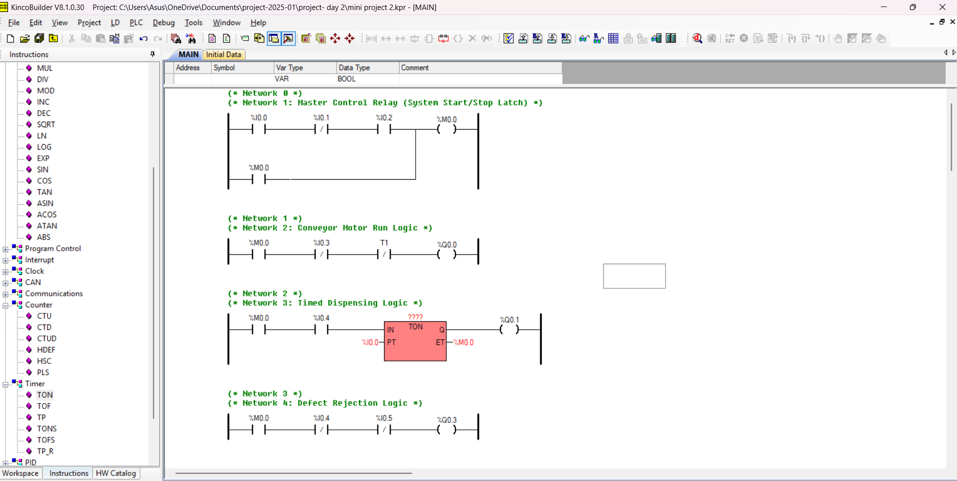

6. HMI Interface Design & Safety Engineering
6.1 HMI Dashboard Layout
The Human-Machine Interface (HMI) screen is organized into three central functional panels:
- Main Overview Screen: Graphical animated representation of conveyor, liquid levels in real-time, bottle counts, and system run state indicators.
- Manual Control & Tuning Screen: Allows authorized maintenance personnel to manually cycle individual valves, jog conveyors, and adjust timer values ($T_{fill}$).
- Alarm & Diagnostic Screen: Displays active fault logs, timestamped E-stop triggers, sensor line disruptions, and low tank volume warnings.
6.2 Safety Interlocks & Emergency Procedures
- Emergency Stop Circuit: Hardware E-stop buttons are wired in series to a dedicated safety relay cutting main 24V DC actuator power directly, independent of PLC software execution.
- Overfill Prevention: High-level float switches trigger direct hardware shutoff to prevent overflow if software timers fail.
- Guard Door Interlocks: Enclosure access doors feature safety switches that force the PLC into a safe hold mode when opened during operation.
7. Implementation Schedule & Bill of Materials
7.1 Estimated Bill of Materials (BOM)
Item | Description | Quantity | Est. Unit Cost (USD) | Total Cost (USD)
1 | Siemens S7-1200 CPU 1214C DC/DC/DC | 1 | $450.00 | $450.00
2 | Siemens KTP700 Basic HMI Panel | 1 | $600.00 | $600.00
3 | Siemens SINAMICS G120 VFD (0.75 kW) | 1 | $350.00 | $350.00
4 | 3-Phase AC Motor with Gearbox (0.5 HP) | 1 | $200.00 | $200.00
5 | Industrial Photoelectric & Laser Sensors | 4 | $60.00 | $240.00
6 | Pneumatic Solenoids & Double-acting Cylinders | 3 | $85.00 | $255.00
7 | Power Supply 24V DC, 10A | 1 | $90.00 | $90.00
8 | Industrial Enclosure, Relays & Wiring | Set | $300.00 | $300.00
Total |  |  |  | $2,485.00
7.2 Project Implementation Gantt Timeline
Plaintext
Week 1: Requirement Analysis & Hardware Selection
Week 2: I/O Mapping, Electrical Schematic Design & CAD Drafting
Week 3: PLC Ladder Logic Programming & Timer Logic Simulation
Week 4: HMI Screen Development & Tag Binding
Week 5: System Integration, Hardware-in-the-Loop Simulation & Testing
Week 6: Final Report Compilation, Safety Audit & Portfolio Submission
8. Conclusion & References
8.1 Conclusion
The proposed PLC-based automated bottling and sorting system design fulfills all project requirements for Task 4. By integrating real-time sensor processing, robust ladder logic control, and comprehensive safety interlocks, the architecture ensures high efficiency, low error rates, and industrial-grade reliability.
8.2 Technical References
- Siemens AG, SIMATIC S7-1200 Programmable Controller System Manual, 2023.
- International Electrotechnical Commission, IEC 61131-3: Programmable Controllers - Part 3: Programming Languages, 2013.
- W. Bolton, Programmable Logic Controllers, 7th Edition, Elsevier, 2019.
- Frank D. Petruzella, Programmable Logic Controllers, 5th Edition, McGraw-Hill, 2017.

